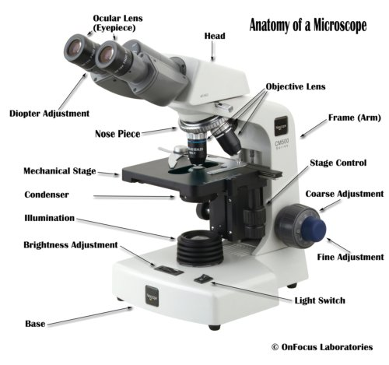

**Eyepiece**: The lens the viewer looks through to see the specimen. The eyepiece usually contains a 10X or 15X power lens.

**Diopter Adjustment**: Useful as a means to change focus on one eyepiece so as to correct for any difference in vision between your two eyes.

**Body tube (Head)**: The body tube connects the eyepiece to the objective lenses.

**Arm**: The arm connects the body tube to the base of the microscope.

**Coarse adjustment**: Brings the specimen into general focus.

**Fine adjustment**: Fine tunes the focus and increases the detail of the specimen.

**Nosepiece**: A rotating turret that houses the objective lenses. The viewer spins the nosepiece to select different objective lenses.

**Objective lenses**: One of the most important parts of a compound microscope, as they are the lenses closest to the specimen.

A standard microscope has three, four, or five objective lenses that range in power from 4X to 100X. When focusing the microscope, be careful that the objective lens doesn’t touch the slide, as it could break the slide and destroy the specimen.

**Specimen or slide**: The specimen is the object being examined. Most specimens are mounted on slides, flat rectangles of thin glass.

The specimen is placed on the glass and a cover slip is placed over the specimen. This allows the slide to be easily inserted or removed from the microscope. It also allows the specimen to be labeled, transported, and stored without damage.

**Stage**: The flat platform where the slide is placed.

**Stage clips**: Metal clips that hold the slide in place.

**Stage height adjustment (Stage Control)**: These knobs move the stage left and right or up and down.

**Aperture**: The hole in the middle of the stage that allows light from the illuminator to reach the specimen.

**On/off switch**: This switch on the base of the microscope turns the illuminator off and on.

**Illumination**: The light source for a microscope. Older microscopes used mirrors to reflect light from an external source up through the bottom of the stage; however, most microscopes now use a low-voltage bulb.

**Iris diaphragm**: Adjusts the amount of light that reaches the specimen.

**Condenser**: Gathers and focuses light from the illuminator onto the specimen being viewed.

**Base**: The base supports the microscope and it’s where illuminator is located.